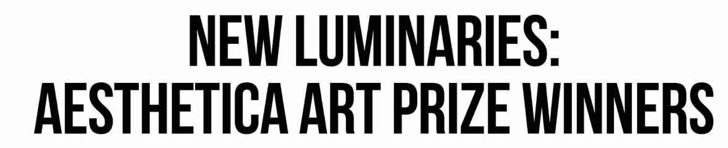

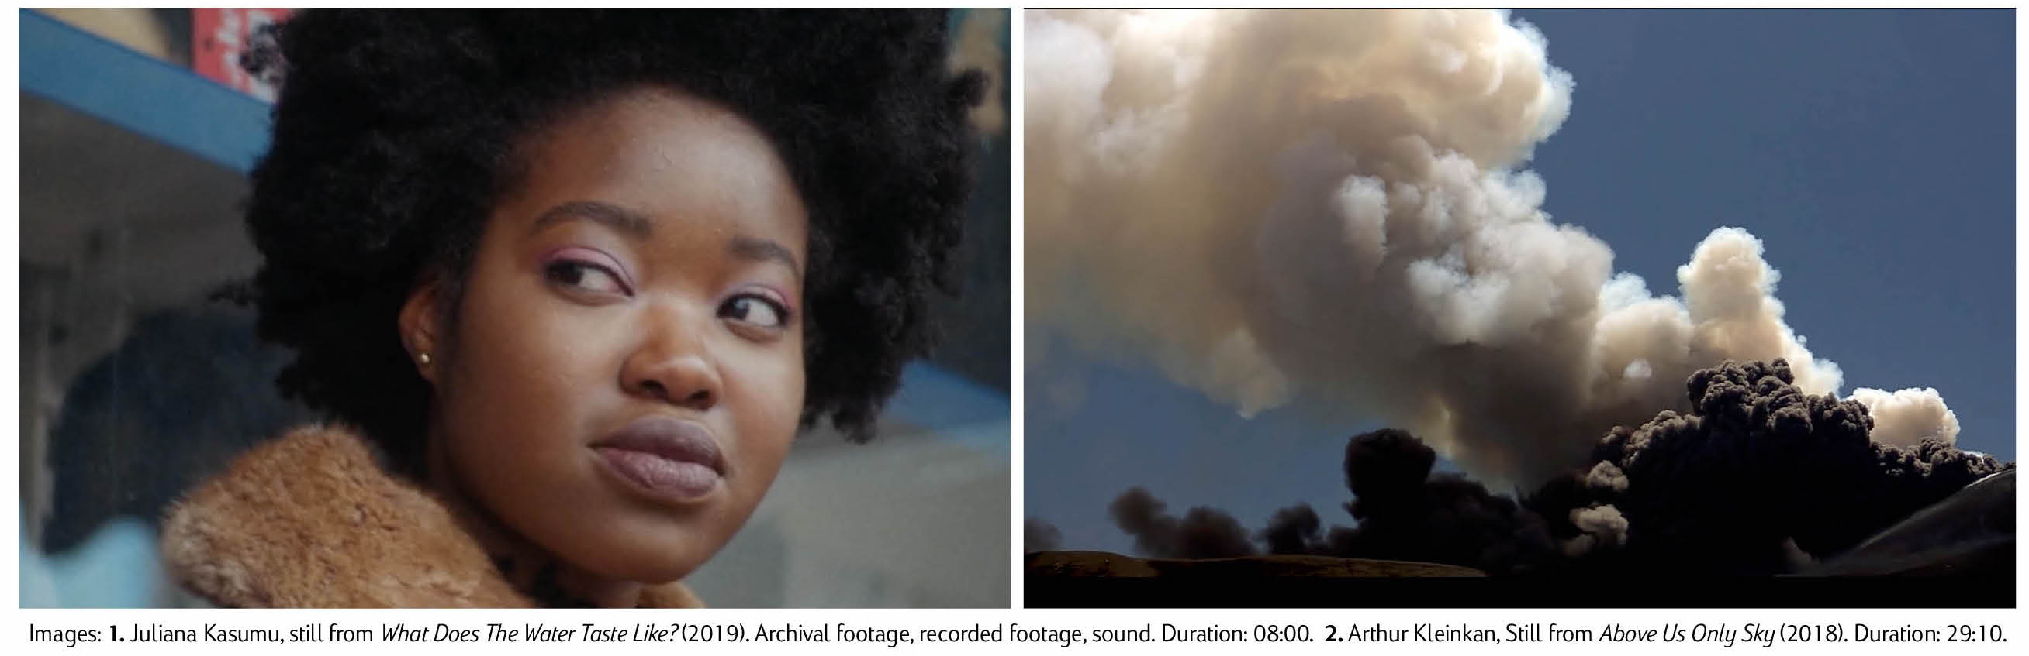

The winners have been announced for the Aesthetica Art Prize. These moving image works
question the world in which we live, from complex identities to notions of truth and storytelling.

The Aesthetica Art Prize is a place of discovery. It is one of the world’s most prestigious awards, sculpting the future of the sector through supporting new talent from across the globe, from Italy to Norway, Singapore to Mexico. Each year, Aesthetica highlights the most talented practitioners from across the globe – trailblazers who digest the very nature of life in the 21st century, further questioning and making sense of a rapidly changing world. This winners of this year’s prize dive into some of today’s most pressing topics, from the construction of identity to the notion of truth.

The 2021 Main Prize-winner is Arthur Kleinjan (Netherlands) with Above Us Only Sky. In this compelling film, a narrator leads us into a magical-realist history that is bereft of fabrication. The story begins with an investigation into a plane crash in communist Czechoslovakia, which one woman survived after an unlikely fall from the air. This event becomes the point of entry to a dense web of seemingly unrelated events that question the logic of chance and synchronicity.

The 2021 Emerging Prize-winner is Juliana Kasumu (UK), with What Does the Water Taste Like? Promoted by intimate conversations, Kasumu questions the production of identity as it relates to her own personal affiliations with the complex ways in which the past and present remain in constant dialogue. This engages in interpersonal speculation regarding identity production and sentiments of “home.” Kasumu’s work presents perspectives on the intimacy between kith and kin.
Cherie Federico, Director of the Art Prize, notes: “Life was complicated before Covid-19, and the pandemic has placed a new set of constraints and challenges on society. The question that runs through all of our minds like a ticker tape is: ‘where do we go from here?’ The winning works are just that – a call to action. These works are covering themes such as the climate crisis, colonial histories, racism, new technologies and the impact they have on our lives. Both Juliana Kasumu and Arthur Kleinjan draw on personal and universal narratives, with immediate artworks that reflect on the times in which we live.”
Kasumu and Kleinjan join Aesthetica’s talented art prize alumni, who continue to demonstrate excellence across the globe. Aesthetica Art Prize finalists have gone on to exhibit at the The Museum of Fine Arts, Houston and Los Angeles County Museum of Art, and be featured in the likes of The Guardian, British Journal of Photography and The Financial Times.
The Aesthetica Art Prize Exhibition runs 28 May – 5 September and is a testament to shared creativity in a time of immense change. Tickets are free, but should be booked in advance on the York Art Gallery website.
Key information for editors:
- The Aesthetica Art Prize has supported a vast number of practitioners over the years. These individuals have since progressed in their careers, gaining funding, residencies and commissions, since the Award’s inception, 14 years ago. Finalists have been featured in both group and solo exhibitions at The Photographers’ Gallery, V&A, MoMA, Barbican and the National Portrait Gallery, amongst others.
- The 2021 shortlisted artists include: Monica Alcazar-Duarte, Andrew Leventis, Chris Combs, James Tapscott, Alice Duncan and Cesar & Lois Collective, Carlos David, Seb Agnew, Kitoko Diva, Christiane Zschommler, Henny Burnett, and Niels Lyhne Løkkegaard. David Brandy, Shan Wu, Cathryn Shilling, Dirk Hardy, Juliana Kasumu, Gabriel Hensche and Erwin Redl.
- The 2021 Aesthetica Art Prize Exhibition runs 28 May – 5 September at York Art Gallery, UK. Entry is free, but booking is essential through the gallery website.
- The 2021 Aesthetica Art Prize Jury includes: Athi-Patra Ruga, artist; Audrey Hoareau, Director, Photo Basel; Chris Zhongtian Yuan, Aesthetica Art Prize Winner 2020; Damon Jackson-Waldock, Deputy Curator, Yorkshire Sculpture Park; Eliza Williams, Editor, Creative Review; Gabrielle Schwarz, Web Editor, Apollo; Karin Rehn-Kaufmann, Art Director and Chief Representative, Leica Galleries International; Kay Watson, Interim Head of Technologies, Serpentine Galleries; Rachel Louise Brown, Photographer and Photography Director, Harper’s Bazaar; Rhea Storr, Artist Filmmaker, Aesthetica Art Prize Winner 2020; Touria El Glaoui, Founding Director, 1-54 Contemporary African Art Fair; Yinka Ilori, Artist and Designer; and myself, Director of Aesthetica.
- The 2021 Aesthetica Art Prize anthology, Future Now: 125 Contemporary Artists, is available to order.
- Entries are open for the 2022 edition: aestheticamagazine.com/artprize/submit
- Press images can be downloaded here.
- The Aesthetica Art Prize is hosted by Aesthetica Magazine: aestheticamagazine.com

