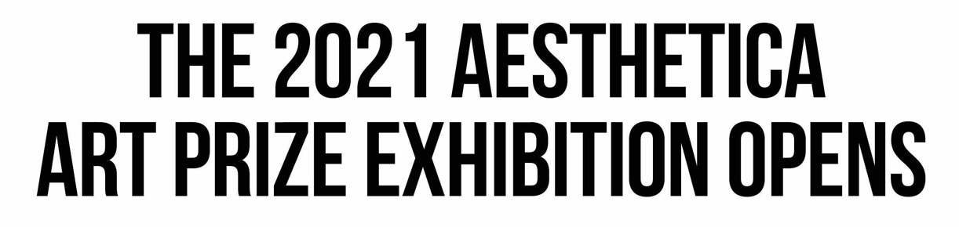

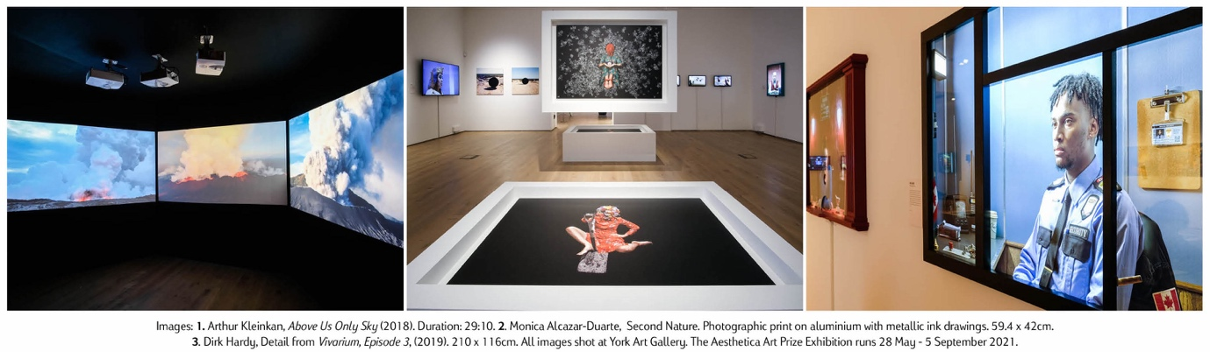

Art is the mechanism through which we can make sense of the world. The Aesthetica Art Prize Exhibition showcases 20 artists from across the globe, new luminaries and chroniclers of our times.

The Aesthetica Art Prize is one of the world’s most prestigious awards, celebrating new talent from across the globe. The annual competition sculpts the future of the sector, providing a platform for those redefining the parameters of contemporary art. Winners receive prize money, exhibition and publication as well as further opportunities for development. Each year, the selected pieces push the boundaries of form and genre, inspiring audiences to see the world in new ways.
The 2021 shortlisted artists unearth the intricate layers of what it means to be alive today. The 20 works, on display at York Art Gallery 28 May-5 September, cover pressing themes, from the climate crisis and colonial histories to racist bias and new technologies. The pieces draw on both personal and universal narratives, unearthing the intricate layers of what it means to be alive today. These works are immediate, compelling and highly relevant works reflecting on a new zeitgeist.
Juliana Kasumu’s artists’ film What Does The Water Taste Like?, questions the production of identity as it relates to the complex ways in which the past and present remain in constant conversation. Kitoko Diva’s The Black Man in The Cosmos is a poetic and experimental art film created as a part of a video installation mixing new forms of Afrofuturism, cyberspace imagery and poetry. It addresses the contemporary identity crisis issue amongst European Afro-descendants.

Henny Burnett’s 365 Days of Plastic takes a critical look at plastic consumption, moulding a year’s worth of packaging and into sculptures that comprise a 4 x 3 metre wall. Andrew Leventis’ Freezer Box (Vanitas) and Refrigerator (Vanitas) include tap into the material realities of the Covid-19 pandemic. The paintings transform Dutch vanitas into 21st century works that consider the experience of wide-spread panic, and the idea of “stocking up” on items in a notion to survive. The 2021 winners, Arthur Kleinjan (Netherlands) and Juliana Kasumu (UK), offer moving image works that question complex identities, as well as notions of truth and storytelling.

Cherie Federico, Director of the Art Prize, notes: “I am honoured to have the opportunity to engage with, and support, so much talent. Every day, I am inspired by these artists. I can only thank them for giving me the opportunity to experience such captivating work. Curating this year’s exhibition was infinitely rewarding. The process is rigorous because there are so many talented artists that apply. The Prize received over 4,000 pieces this year, which was then longlisted to 125, and then a further 20 artists were selected for the exhibition, based on originality, skill and technical ability.”
The Aesthetica Art Prize Exhibition runs 28 May – 5 September and is a testament to shared creativity in a time of immense change. Tickets are free, but should be booked in advance on the York Art Gallery website.
Key information for editors:
- The Aesthetica Art Prize has supported a vast number of practitioners over the years. These individuals have since progressed in their careers, gaining funding, residencies and commissions, since the Award’s inception, 14 years ago. Finalists have been featured in both group and solo exhibitions at The Photographers’ Gallery, V&A, MoMA, Barbican and the National Portrait Gallery, amongst others.
- The 2021 shortlisted artists include: Monica Alcazar-Duarte, Andrew Leventis, Chris Combs, James Tapscott, Alice Duncan and Cesar & Lois Collective, Carlos David, Seb Agnew, Kitoko Diva, Christiane Zschommler, Henny Burnett, and Niels Lyhne Løkkegaard. David Brandy, Shan Wu, Cathryn Shilling, Dirk Hardy, Juliana Kasumu, Gabriel Hensche and Erwin Redl.
- The 2021 Aesthetica Art Prize Exhibition runs 28 May – 5 September at York Art Gallery, UK. Entry is free, but booking is essential through the gallery website.
- The 2021 Aesthetica Art Prize Jury includes: Athi-Patra Ruga, artist; Audrey Hoareau, Director, Photo Basel; Chris Zhongtian Yuan, Aesthetica Art Prize Winner 2020; Damon Jackson-Waldock, Deputy Curator, Yorkshire Sculpture Park; Eliza Williams, Editor, Creative Review; Gabrielle Schwarz, Web Editor, Apollo; Karin Rehn-Kaufmann, Art Director and Chief Representative, Leica Galleries International; Kay Watson, Interim Head of Technologies, Serpentine Galleries; Rachel Louise Brown, Photographer and Photography Director, Harper’s Bazaar; Rhea Storr, Artist Filmmaker, Aesthetica Art Prize Winner 2020; Touria El Glaoui, Founding Director, 1-54 Contemporary African Art Fair; Yinka Ilori, Artist and Designer; and myself, Director of Aesthetica.
- The 2021 Aesthetica Art Prize anthology, Future Now: 125 Contemporary Artists, is available to order.
- Entries are open for the 2022 edition: aestheticamagazine.com/artprize/submit
- The 2021 press pack can be downloaded here. Contact kate@aestheticamagazine.com for high res images.
- The Aesthetica Art Prize is hosted by Aesthetica Magazine: aestheticamagazine.com

